THE GODDESS GARDEN ECO-RESORT
Playa Grande
Cahuita, Province of Limon
Costa Rica
Tel. +506 2755 0070
www.thegoddessgarden.com

The Goddess Garden Eco-Resort is located at the Caribbean Coast of Costa Rica in Central America.

Climate
The Caribbean Coast of Costa Rica has a tropical climate, lush green the whole year, with a mean annual temperature of 78 F ( 26 C ).

Language
The official language is Spanish, but English is very common at The Caribbean Coast of Costa Rica.

Our Clients
We use the resort mainly as a Spiritual center, because it is our personal priority. Our groups are coming from the US, Canada and Europe.
We use the hotel also as a conference center. As regular clients we have government institutions and foundations of conservation of nature and others. Furthermore, it is a regular hotel with the possibility of an all-inclusive service for our clients. It offers great possibilities to expand.

Nature
Tucked into the jungle aside the Caribbean Sea, the hotel is a magical place to connect with nature. It offers 3.8 ha (9.4 acres) of private, lush, and beautiful rain forest surrounded by tall trees, tropical flower gardens and a variety of animal life, like monkeys, sloths, coatis, armadillos, toucans, parrots, hummingbirds, butterflies etc.
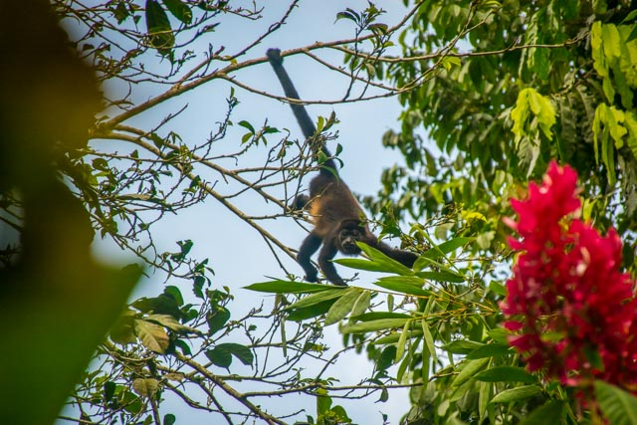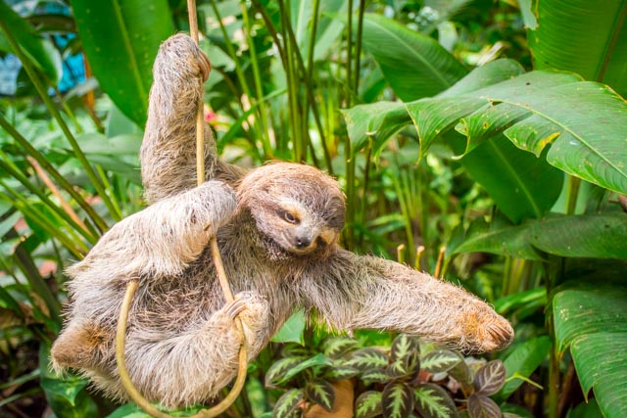

Local and international art work is an important part of our facilities and can be found in the gardens and buildings.
You will see the oldest and most amazing tree of Cahuita, 360 years old, with roots, as tall as a man, in reality it is a natural temple.
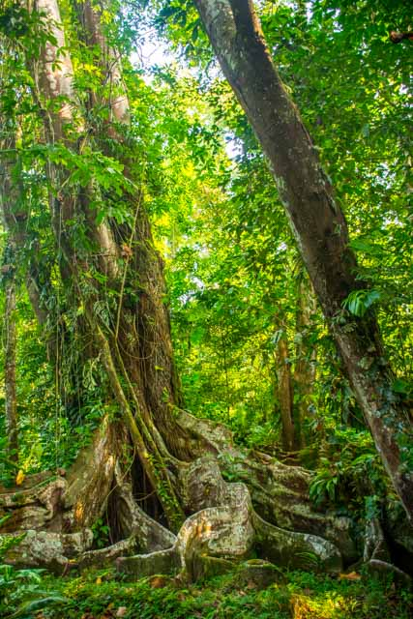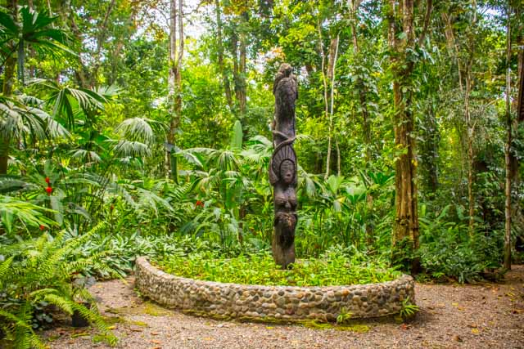

A frog pond invites for night tours to see all the wonderful colored frogs of Costa Rica.
Nature is breathtaking with its flora and fauna and yet we are next to a 10 km long pristine beach. It is the perfect combination for a resort to offer pure nature, serenity, wild life, beach, Caribbean Sea and adventures excursions in the neighborhoods.
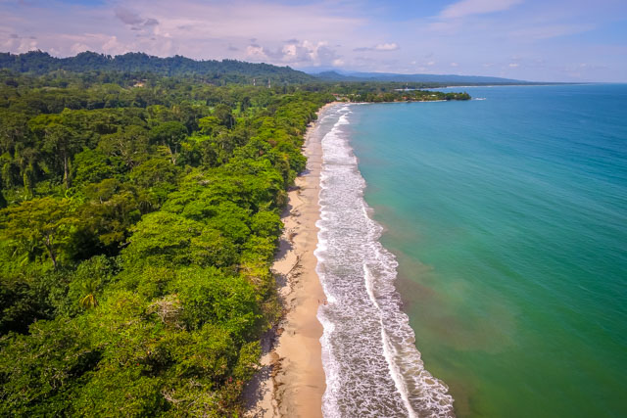
Cahuita is 2 miles away and home of an important National Park with a stunning coral reef in front. It is an inviting place for hiking and snorkeling tours.

Buildings
The Goddess Garden Retreat’s spiritual center has two floors, where the view of the rainforest expands to 360 degrees. It is designed to give you a wonderful feeling, putting you in touch with nature during your sessions. The upper space is 200 m2 (2150 square feet) with a precious wooden floor.
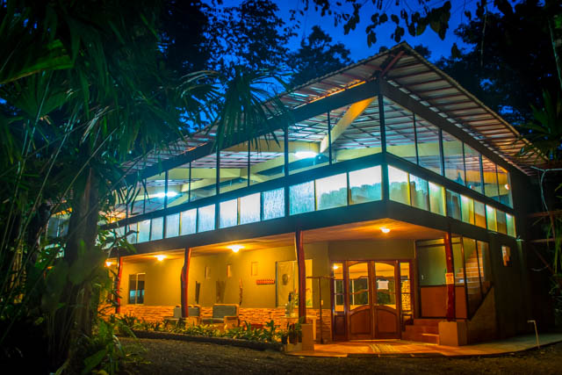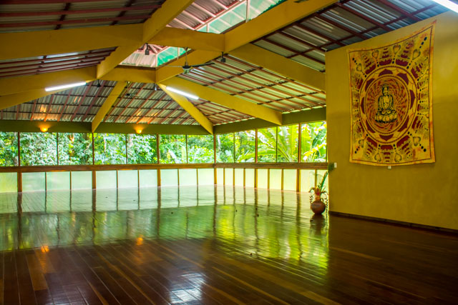

The conference room is designed for 100 people and offers the newest audio and video system. It is equipped with air conditioning. In the back of the room, a built in waterfall with tropical plants delight the eyes.
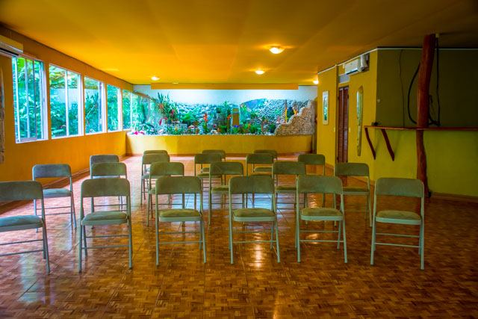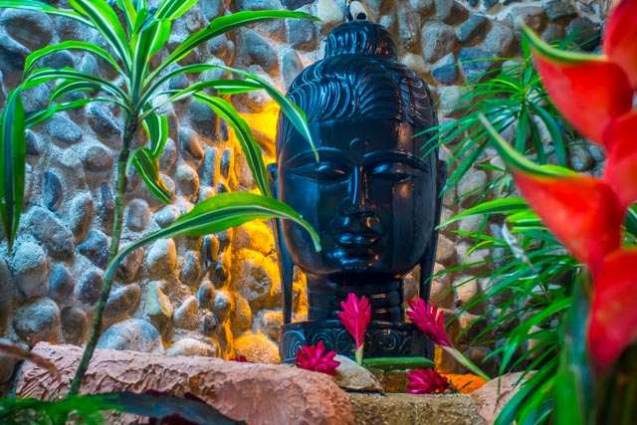
A round pavilion with wooden floor is the third space we offer for sessions, meetings, receptions and other events.
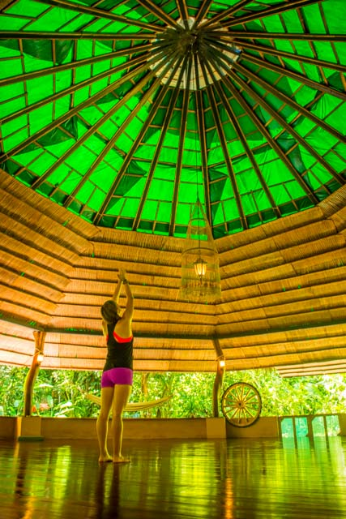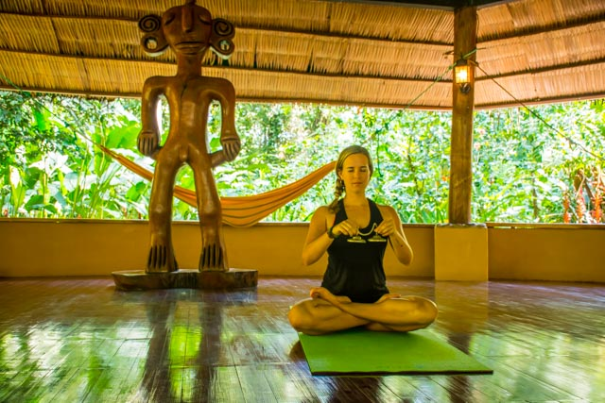

Our large swimming pool has a Jacuzzi with massage jets and a beach with massage bubbles.
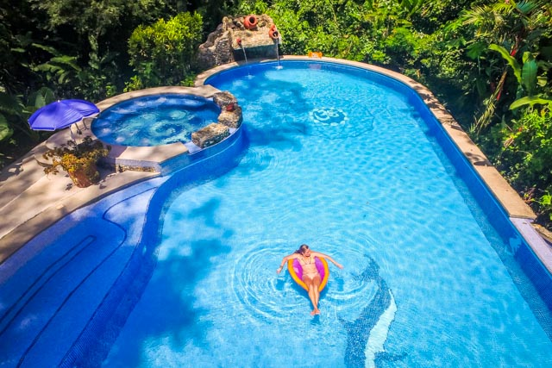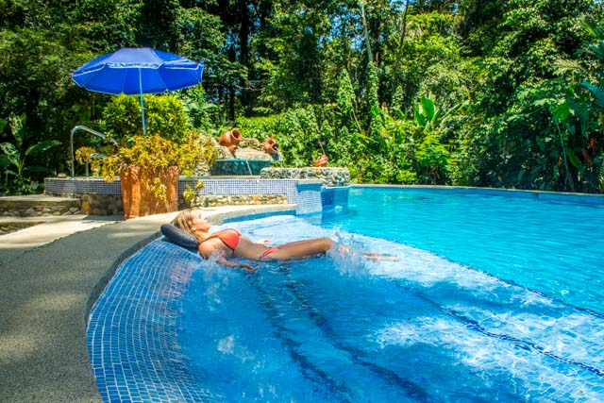

Next to the pool you can find the fully equipped restaurant with 52 seats and bar and hang out area.
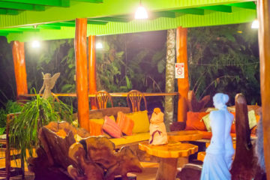

Our Spa has two massage parlors and space for nail painting and hair braiding.
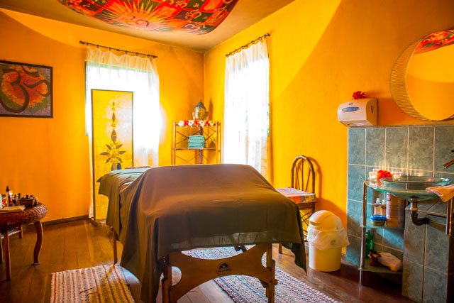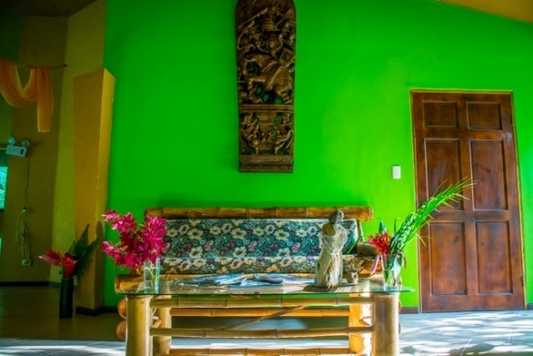

Four buildings contain our 16 elegant rooms. 12 of the rooms are double rooms with two Queen Size beds each. Additionally, we have 4 dorm style rooms with Twin size beds for 3-6 people each. In total we can accommodate 50 persons in separate beds. All rooms have private bathrooms with solar heated hot water. A room for disabled persons according to law is within the premises of the hotel.
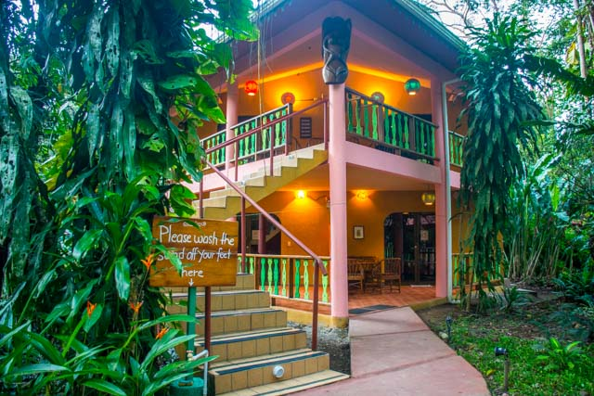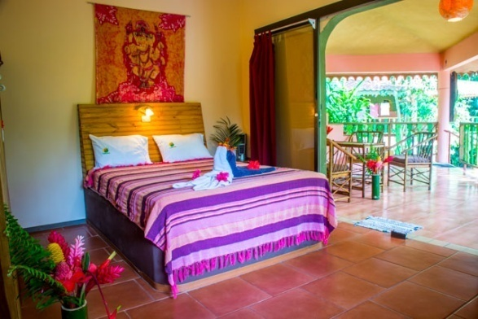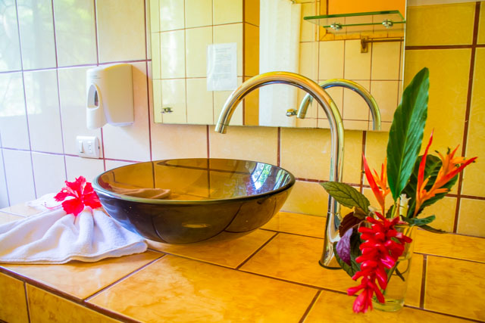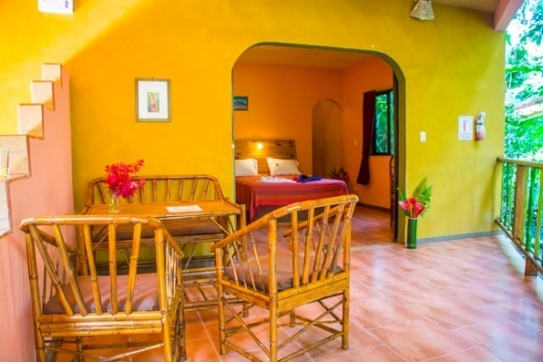

Video
https://youtu.be/HQ8FB6PAScs

Future
The future is bright for tourism at the Caribbean side of Costa Rica since there is an economic revival due to the completion of the port of Limon. There are 135 cruise ships coming to Limon annually. Limon is only 40 minutes away from our resort. We receive visits from the cruise ships as well.
The government is also creating a 4 way highway from Limon to San Jose. This new road will shorten the time between the capital and the Caribbean towns. The airport in Limon is being refurbished and there are daily flights from San Jose to Limon that take only 30 minutes. In the high tourist season the flights are augmented to 3 daily.

Ownership
The property of The Goddess Garden Eco-Resort is owned by 2 corporations constituted and existing pursuant to the laws of the Republic of Costa Rica, with its legal quarters in Cahuita of Talamanca, Limon, Costa Rica.
Las Hadas del Caribe, holder of Corporate I.D. Number 3-101-441567
Owns 47% of the property (1.8 hectares / 4.45 acres)

La Diosa Esmeralda, holder of Corporate I.D. Number 3-101-603164
Owns 53% of the property (2 hectares / 4.94 acres)

Shareholders / 50% each
The two companies are represented by its joint agents with sufficient Power of Attorney:
Jacqueline Buerkler
Swiss Citizen, lives in Costa Rice since 1999

Marcelo Ruiz
American citizen, lives in Costa Rica since 2003

The property has titles registered in the National Registry of Costa Rica.

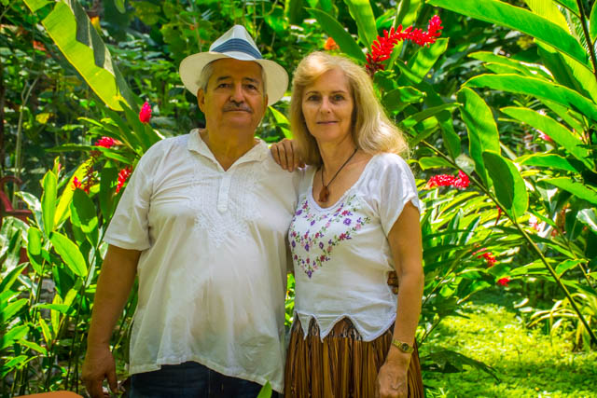

Short history
Jacqueline was born in Switzerland where she grew up and achieved a PhD in natural sciences from ETH Zürich. She always liked to travel and in early years traveled through Europe, Asia and the continent of America. She changed her home to Costa Rica in 1999.
In 2001 she built a home and lived on the property in the midst of the jungle. In 2003 she met Marcelo who had emigrated from Chicago to Cahuita. He left his taxi business and his teaching job behind and started a new life in Costa Rica.
Together they created the vision of The Goddess Garden. The serenity of the rainforest and the pristine beaches of the Caribbean Sea inspired the idea to create an intentional place for transformation: The Goddess Garden Eco-Resort.
In 2005/06 the project initiated with the building of the pool, the restaurant, the event center and the pavilion. In the following years they bought four adjacent properties and expanded the project. The Spa and the first rooms very built in 2008 and the last rooms in 2010.
The doors to the public opened in 2009.
Since then there has been a story of success with hundreds of happy clients enjoying what we offer: beauty, calmness and peace.

Our Vision
Costa Rica is home to a rich variety of plants and animals and contains one of the world's highest biodiversity. It was our goal to be part of the conservation of the natural treasures of Costa Rica.
We wanted to make the rainforest accessible to a conscious tourism, enjoying it without destroying it.
We are also part of the Turtle Rescue Project Cahuita which works for the protection of the Leatherback Turtles. Those gigantic turtles lay their eggs in the sand of Big Beach close to the property between February and June of each year. Their numbers have decreased substantially in the last 20 years and it is our duty to take part of their conservation.
Our vision was to be pioneers of ecotourism. It is a fast growing branch of tourism that combines vacation with consciousness to preserve our planet. Reconnecting with nature is a healing experience for your inner self and personal growth.

Reason for selling
We sell our unique hotel because of retirement. It is an amazing spot for nature lovers.

Asking price:
The resort with all buildings and 3.8 ha (9.4 acres) of rain forest
2 200 000 USD
There is more land available on request.

